Year 5 Curriculum Map – Autumn 1 (Half term) 2024
Literacy  This term we will be starting with non-fiction unit on biographies. We will then read Windrush Child by Benjamin Zephaniah. Finally, we will finish the term looking at performance poetry.  The children will continue to work on their literacy skills of:  - Writing for a range of genres.  - Using a full range of punctuation in their work e.g, hyphen, semi-colons  - Consistently using the correct grammatical structures, for example writing in the correct tense, using active and passive sentences, classifying word groups.  - Exploring and clarifying new vocabulary.  - Building on inference, retrieval and summarising skills when answering an unknown text.  - Practice spelling skills and rules. |  | Maths  In maths the children will continue to follow Maths Mastery to develop their mathematical skills. This term the children will be learning:  Reasoning with large whole numbers:  Read, write, order and compare numbers up to one million •Round numbers within one million to the nearest multiple of powers of ten •Read Roman numerals up to M  Addition and subtraction:  Use rounding to estimate •Use a range of mental calculation strategies to add and subtract integers •Illustrate and explain the written method of column addition and subtraction •Select efficient calculation  Line Graphs and timetables: •Complete, read and interpret data presented in line graphs •Read and interpret timetables including calculating intervals  
Science – Forces  What will we know by the end of the unit:  - To be able to identify different types of forces – pull, push, gravity.  - To be able to identify which forces act upon an object.  - To identify the effects of air and water resistance.  - To understand the effects of friction.  - To explore and understand how pulleys and gears work and their importance in making lives easier.  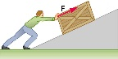 | RHSE- Healthy Bodies, healthy minds  (Valuing our bodies and minds)  What will we know by the end of the unit:  How to stay healthy, both physically and mentally. How to maintain wellbeing and prevent illness; how to develop a healthy, balanced lifestyle; and the consequences and effects of different habits and choices. It encourages the development of positive self-worth and recognition, what might affect or influence unhealthy ways of thinking, and how to overcome this. |  | Computing- Online Safety and Word processing/Google Slides  What will we know by the end of the unit:  To understand the positive behaviours to demonstrate whilst online and how to stay safe;  - To be able to create a word document.  - To be able to edit text and images.  - To be able to use different styles to format a document.  - To be able to publish a document.  
Year 5 Curriculum Map – Autumn 1 (Half term) 2024

Art — Kara Walker  In our Art lessons we will be learning about the famous American artist Kara Walker.  What will we know by the end of the unit:  - To learn about the artist Kara Walker and explore some of her artwork  - use a variety of drawing techniques to add effects, e.g. shadows, reflection, hatching and cross-hatching;  - To explore creating artwork as a collage using black paper and black paint.  - To use pencil techniques to illustrate an African folktale.  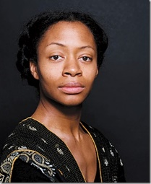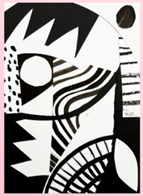 | History—Ancient Benin  What will we know by the end of the unit:  - How and where the kingdom of Benin developed  - To understand how the Kingdom of Benin links to the British timeline and the World history timeline.  - To understand the culture and religious beliefs of Ancient Benin.  - To explore the Benin arts – bronzes and other sculptures and the craftsmanship guilds that created them.  - To learn and understand how and why the Benin kingdom came to an end.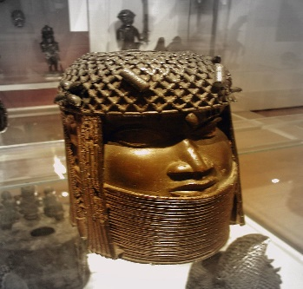 |  | RE- What do the miracles tell us about Jesus?  What we will know by the end of the unit:  To know and remember the core concept: Incarnation.  To know and remember the following miracles: Jesus turning water into wine at the wedding of Cana in Galilee, the feeding of the 5000, the woman who touched Jesus’ garment, the miracle of the raising  of Lazarus.  To understand how the miracles of Jesus signpost us to who Jesus is – both human and divine – incarnation. (To note: Jesus is able to perform miracles because he is God, not because he has faith in God.)  