Year 5 Curriculum Map – Spring Term 1&2 (2024)

Literacy  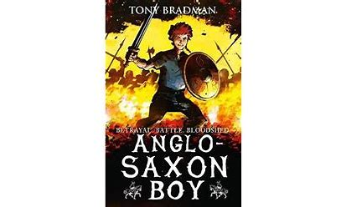  This term pupils will be enhancing their writing skills reading and analysing different biographies. They then will write biographies. Pupils will read Anglo-Saxson Boy by Tony Bradman, before then reading and writing poetry. They will practise skills of:  Reading Prediction/inference/clarifying/questioning/summarising/making links and evaluating. Writing Chronological reports, diary entries, letters and poetry. Grammar – past tense/perfect past tense/past tense participle and past progressive tense. |  | Maths:  Pupils will complete the following units.  U5 Perimeter & Area  U6– Fractions and Decimals  U7– Angles  Unit 8—Fractions and Percentages  Unit 9 Transformations  Key fundamentals using all 4 number operations will be continued to be taught and practised throughout these units. Prior skills will be practised and refreshed during Maths Meeting sessions throughout the week, so that pupils connect prior learning and master applying them. | Science – Earth & Space/Animals Including Humans  This Photo by Unknown Author is licensed under CC BY-SA  1) Pupils learn the names and order of the planets in the Solar system. They explore the movements and relationships of celestial bodies – The Sun, Earth and Moon. Pupils explore the different ideas about the Solar system – geocentric and heliocentric models. Pupils explore night and day and how this can be different dependent on where you live on Earth.  2) Pupils look at comparing different lifecycles of animals and set up observational tasks of the lifecycle of a butterfly. They look at the different types reproduction in plants.
Computing:  Coding using Purple Mash & Online safety- Focus on copyright & personal identity | Art –  use inspiration from famous artists esp: Barbara Hepworth to replicate a piece of work; reflect upon their work inspired by a famous notable artist and the development of their art skills; 3D sculptures—creating mountainous models | PE  Pupils will be practising swimming skills every Monday. In addition they will be focusing on static balance and coordination. Pupils will be taught and practise how to improve their own personal goals – personal best. | RSHE – Families and Committed Relationships  Core Learning Skills  Improving our own Learning and Behaviour  To be able to identify what is important in a healthy, positive relationship; to know that a range of different families exist in the community and have respect for diversity; to know our own thoughts and beliefs about committed relationships.
RE: Sikism beliefs  - How did Nanak become Sikhism’s first Guru?  Why is the Guru Granth Sahib important to Sikhs?  How is equality shown in the langar?  What does a Sikh wedding ceremony tell us about Sikh beliefs about marriage?  What was Guru Arjun Dev’s greatest achievement?  - 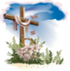What happens in churches during Lent, Holy Week and Easter Sunday? Pupils explore the concept of Salvation. |  | History— Anglo Saxons & Vikings  To explore what Britain was like before the first Viking invasions, using key events on a timeline.  To be able to explore the Viking invasions of Britain.  To be able to understand where and why the Viking settlements were in Britain and how this affected the Anglo-Saxons.  To explore events which led to why King Alfred was dubbed ‘Alfred the Great’.  To explore what life was like for Vikings living in Britain. | Geography: Mountains:  To identify the most famous mountains and their ranges in Europe and the World  To know the most famous and well-known mountains of the United Kingdom.  To use maps to key areas of higher ground in countries and their key physical features, including mountains.  To explain how different types of mountains are formed.  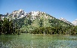  To use maps to locate and to describe the key features of a mountain range.

