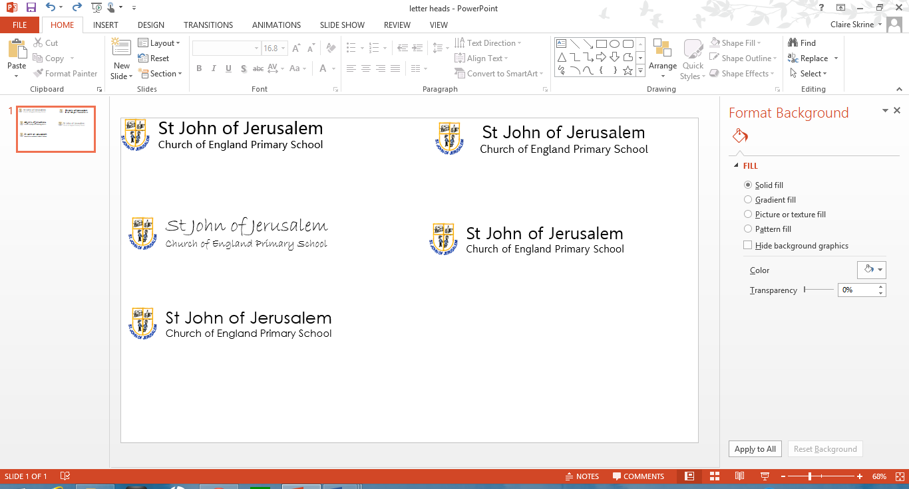
PSHE/RSE Whole School Year Plan 2024-2025
Term | Autumn 1 | Autumn 2 | Spring 1 | Spring 2 | Summer 1 | Summer 2
PSHE and RSHE is taught in an age appropriate manner. We start with Health and Wellbeing to ensure all our pupils are ready and prepared to be successful at school. We ensure that they are ready for their learning. We conclude with Living in the Wider World to deal with change for all pupils transitioning to a new year group or school. To support all learners becoming responsible citizens, we incorporate our Core Learning Skills within our school values and ethos. They complement the PSHE/RSHE curriculum and is celebrated on a weekly basis as a whole school community.
PHSE Termly focus/theme | Health & Well being |  | Relationships |  | Living in the wider world
PHSE | Healthy body & Minds | Healthy & Happy Friendships | Families & Committed relationships | Caring & Responsibility | Similarities & Differences | Coping with Change
CLS focus/theme | Learning with Others | Developing Independence & Responsibility | Improving our own learning and behaviour | Developing a sense of self-worth & understanding of self & of others. | Thinking Skills | Speaking & Listening

