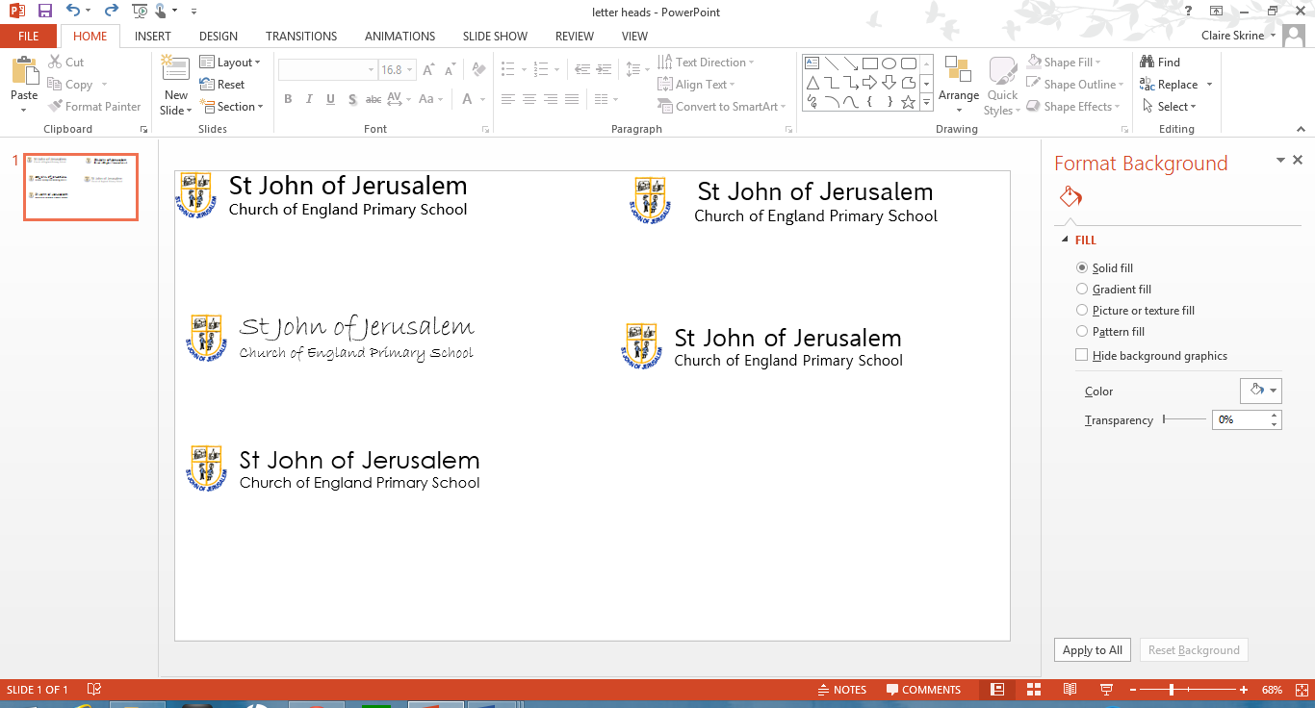

**Guidance & Procedures for Off-Site Visits**

Note: This policy will be reviewed annually

**Please note that this document should be read in conjunction and with reference to the London Borough of Hackney's Health and Safety guidelines chapter 23.**

**The importance of trips and off-site education**

Visits to museums, galleries, zoos, markets, shops and other places of interest are a core part of the curriculum at St John of Jerusalem C of E Primary School and form the basis of work of quality and depth. Every class aims to undertake three visits a term related to their topic work, and in Year 6, there is the traditional residential week. This is an ambitious aim that requires careful and consistent planning and preparation by class teachers.

**Responsibilities of the Head Teacher**

The Head Teacher takes overall responsibility for any trip planned, which includes:

* Overseeing and advising on the decision-making process, as appropriate to the experience of the Group Leader
* Ensuring that the Group Leader has followed the requisite planning steps (see below).
* Ensuring that risk assessments are done and signing off these risk assessments
* Authorising the trip to go ahead.
* Ensuring that each class, each year take a good variety of trips
* Acting on feedback gained on trips to advise future planning.

**Responsibilities of the Group Leader**

The following are what we expect of the "Group Leader" – the teacher organising the trip:

* Before making any booking, check with the Headteacher about the suitability of dates and staff availability to accompany you. The Headteacher must authorise all trips
* Give sufficient notice to the school secretary so that she can organise and communicate changes to lunch-time arrangements and arrange insurance cover and any coaches that need to be booked
* Ensure that a specific letter with a permission slip goes home to parents two weeks in advance of the trip
* Secure free tube travel; tickets must be booked online at least two weeks in advance. Details of the website are in the staffroom
* Collect voluntary contributions from parents
* Under a reconnaissance of the visit centre and the journey there and back, undertaking a "Risk Assessment". A copy of the Risk Assessment must be provided to all teachers and supervisors involved in the visit
* Make appropriate enquiries about the museum/centre and complete any pre-information they ask for.
* Organise a planned programme
* Check toilet arrangements en route and at the visit site
* Have a plan for where to eat, and, if relevant, a wet weather option
* Make appropriate arrangements for those children requiring medication
* Brief parent volunteers at 8.45 am or before leaving on the day of the trip
* Ensure all parents who are helping have a copy of **Appendix 3** (stored in the office)
* Ensure that children are asked to wear appropriate clothing
* Ensure there is adequate water for both journeys
* All Supervisors and Teachers must hold a list of pupils and adults on the excursion
* The Headteacher will always support Early Career Teachers (ECT) in planning and undertaking their first trip
* Telephone the school upon arrival at the destination
* Whilst at the destination, regular head-counts must be taken, in particular before leaving the venue
* Wherever possible and reasonable, measures should be in place to identify pupils easily. Pupils should not display personal identity but should wear badges indicating the school and emergency contact number.
* Further measures such as high visibility vests may be considered for younger age groups.
* Agree on procedures for when a pupil becomes separated from the group. Such procedures should be notified to all pupils and supervisors and include rendezvous points.

**Adult/child ratios**

For under-8s, we follow Hackney LEA's guidance of a ratio of 1:6, e.g. 5 adults accompanying the trip (at least 2 of whom should be school staff members).

For over-8s, the ratio is 1:15, but we operate 1:10, e.g. 3 adults accompanying the trip (at least 2 of whom should be school staff members).

Teachers are responsible for negotiating support from other adults in school and any 'swapping' of support time.

There is a strong tradition of parent volunteers that we value. Teachers must publicly ask for parent helpers and ensure a fair balance of parents who help. We ask that pre-school siblings do not come, however, to focus on the class.

**Transport on trips**

We use a variety of transport methods and conduct an individual Risk Assessment and decision for each trip, balancing cost, ease of journey, the cumulative cost of previous trips and time of travel. We are well situated to use the tube and bus network to which we can apply for free tickets.

Parental permission is sought for all trips. The journey is part of the trip; the only circumstances where a child may travel separately are if they have compelling special needs that make group travel on public transport difficult. If a parent is not giving permission for the trip, we will always respect this and make arrangements for the child to be in another class.

We discuss with all parent helpers what to do in the event of a security alert whilst travelling (**see Appendix 3)**. Still, we would not proceed with a trip if we were alerted to any heightened security risk prior to leaving.

**Crossing roads and walking in public**

Pupils should walk two abreast, with staff members at the front and rear. Road crossings should be used where possible, and the group leader should be aware of all potential hazards en route. The children should be reminded of road safety principles and should be reminded to show courtesy to other users of pathways. At all times, they must be expected to behave in a manner consistent with their own and others' safety and behave in a way that gives a good impression of their school.

The Hackney LEA distinguishes between two types of trips as follows:

**Category A trips – 'high risk.'**

Following Hackney LEA's guidance, this category includes our Year 6 residential trip, day visits abroad and any day trips that involve work near rivers, the sea, and other waterways.

Governors must be notified of these trips and be aware of the risk assessments. The Head Teacher will do this in the Governing Body meeting before the trip date or via email if timings prevent this.

**Category B trips**

This includes all other trips. For each of these trips, teachers are asked to complete a simple A4 proforma detailing travel arrangement, adult support, and any particular risks they have assessed. These are kept in the School Office. **See Appendix 1.**

**Expectations of parent volunteers**

Parent helpers are asked to attend a briefing meeting on the day of the trip. Simple health and safety and emergency procedures will be explained. **See Appendix 2 and 3.**

Remember that parent helper are volunteers – treat them well, buy them a coffee, thank them etc. We do not expect parent volunteers to have been police checked as they do not have unsupervised control of the children. It is for each teacher to outline the expectations of their helpers, but a few core guidelines are:

* Parents cannot be expected to undertake the same duties as a teacher
* Refer all concerns, including discipline, to the teacher in charge
* No personal use of mobiles on the trip
* No buying food or souvenirs for their child or any other
* No smoking in front of the class – but cigarette breaks allowed!

It is not reasonable to give a parent helper any child who may present with behavioural problems.

**Pupils with disabilities**

St John of Jerusalem is an inclusive school, and we actively seek to overcome barriers to learning for all pupils. We will make every effort to include all pupils in our educational trips. If a child with disabilities is part of the trip, extra information must be sought about the child's specific needs from the parents and other professionals. A child's Special Needs must also be discussed with the place of visit and specific risks/problems assessed. There must be a specific adult in attendance for this child.

**Spending money**

It is school policy that children do not take money on trips, with the exception of the residential week at Kingswood.

**Legal context and duty of care**

The governors' responsibility is to establish policies and procedures and monitor their implementation. It is the responsibility of the Headteacher to ensure the proper management of all school journeys and off-site activities in accordance with these policies and procedures.

The legal liability of an individual teacher or Headteacher for an injury sustained by a pupil on an outing depends on whether or not the injury is a direct result of some proven negligence or failure to fulfil 'duty of care' on the part of the teacher or Headteacher.

The standard of care required of a teacher can be reasonably expected from teachers generally applying skill and awareness of children's ages, needs and abilities. In addition, the law expects that a teacher will do what a parent with care and concern for the safety and welfare of their own child would do, bearing in mind responsibility for a group of pupils.

The duty of care includes a duty to anticipate risks and manage these risks with regard to their own safety and those in their care. To this end, all teachers are expected to visit the site/museum beforehand and undertake a Risk Assessment. This is recorded on a proforma – **see Appendix 1.**

Educational day visits, domestic residential and international trips can go from September 2021. A full and thorough risk assessment will have been carried out for all visits. We will also refer to any public health advice, such as hygiene and ventilation, as part of the risk assessments.

First Produced December 2010

Last reviewed December 2021

**APPENDIX 1**

**ST JOHN of JERUSALEM C of E PRIMARY SCHOOL**

**OFF-SITE VISIT RECORD SHEET – RISK ASSESSMENT**

**NOTE: Must be completed before going on the trip**

Class: Date of trip:

Visiting:

**Accompanying Adults**:

School staff:

Parents:

Other:

Transport:

Have you done a pre-visit? YES**/NO** If so, please record the date:

Are there any particular risks or considerations you have taken into account having done this?

**NOTE: If your trip involves water, we must have adequate notice as this is category A**

Signed: ……………………………………………………… Date:

Print Name:

(BLOCK LETTERS)

**APPENDIX 2**

**ST JOHN of JERUSALEM C of E PRIMARY SCHOOL STAFF**

As previously stated, staff are expected to have done a pre-visit and Risk Assessment with regard to the journey. Remember to complete the A4 Pro-forma on the day -– the school secretary usually puts it on the register.

The following are additional measures in light of the heightened security risk since the events of July 2005:

* You need to arrange a 5-10 minute meeting with your parent helpers and any other staff – 8.45 am, prior to departure - to go over the protocol - Appendix 3
* You need to have all the mobile numbers of the adults with you and have your mobile phone with you
* Make sure you know the school number and/or have it in your mobile
* Have clear groups, with children assigned to an adult, for the journey. Make sure all adults have a copy of this list. If you have lots of adults, consider not having a group yourself. Putting a child with their parent is at your discretion; this need not necessarily be the case.
* Always have a large bottle of water or two. Children will be asked to include a small bottle of water in their lunch as a matter of course
* In an emergency such as an evacuation, each adult is responsible for getting their group to safety.

If you are on a trip and there is a security alert, the guidance is to:

* Find a safe place – a public building is suggested
* Use a mobile or landline phone to call the school
* Stay put, following local emergency services advice.

Once you have contacted the school, it is the school's responsibility to contact parents.

Mobile coverage can be unreliable. Ensure you carry loose change to call from a landline or contact the school via email or fax. Contact details are as follows:

St John of Jerusalem C of E Primary School, Kingshold Road, Hackney, London, E9 7JF

Tel: 020 8985 0730 Fax: 020 8985 6337

Email admin@st-johnjerusalem.hackney.sch.uk

**APPENDIX 3**

**ST JOHN of JERUSALEM C of E PRIMARY SCHOOL**

**PARENTS, CARERS AND VOLUNTEERS**

**Firstly thank you for coming along on the trip to help!**

So that we can ensure consistent practice from all parents, we would ask that you adhere to the following guidelines:

* Please enter into the spirit of the trip and enjoy it!
* Expect high standards of behaviour on the trip/journey and keep the children calm
* Listen to the teacher when asked and model this to the children too
* Do not smoke in front of the children or eat/chew during work sessions
* Please do not give your child or any other child money for a treat or buy one for them
* Do not leave your group unattended.

You will be given a group of no more than six (6) children for the journey. Please ensure that they are with you at every stage of the trip.

In the unlikely security alert, please lead your group to safety following emergency services advice. Do not be concerned if you become separated from the rest of the group.

If you are on a trip and there is a security alert, the guidance is to:

* Find a safe place – a public building is suggested
* Use a mobile or landline phone to call the school
* Stay put, following local emergency services advice.

You need to have all the mobile numbers of the adults with you and have your mobile with you.

Mobile coverage can be unreliable. Ensure you carry loose change to call from a landline or contact the school via email or fax. Contact details are as follows:

St John of Jerusalem C of E Primary School, Kingshold Road, Hackney, London, E9 7JF

Phone: 020 8985 0730 Fax: 020 8985 6337

Email [admin@st-johnjerusalem.hackney.sch.uk](mailto:admin@st-johnjerusalem.hackney.sch.uk)